PROGRAM 8

/\* program to use for loop \*/

#include<stdio.h>

int main()

{

int i;

for(i=1;i<11;i++)

{

printf("\n%d", i);

}

return 0;

}

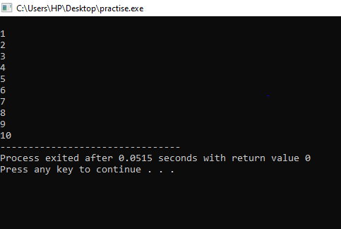

/\* Program to use nested for loop \*/

#include<stdio.h>

int main()

{

int i, j;

for(i=2;i<100;i++)

{

for(j=2;j<=(i/j);j++)

if(!(i%j))

break;

if(j>(i/j))

printf("%d is prime\n", i);

}

return 0;

}

